PART C ASSIGNMENT SPECIAL TOPIC
Part C: Specialized Technology, Fundamental Concepts
C1: Fundamental concepts and how the technology works
The specialized technology selected for this project is under Natural Language Processing (NLP) and Speech Language Processing, specifically combining Automatic Speech Recognition (ASR), Neural Text-to-Speech (TTS), and Lightweight Local Large Language Models (LLM). Together with Optical Character Recognition (OCR) as the document input step, these technologies enable a computer to read printed text aloud, listen to human speech, evaluate pronunciation quality, and generate natural language feedback.
At the fundamental level, the speech and NLP operate through 4 core concepts:
- Turning Sound into a Visual Map:
When a child reads into the microphone, the computer captures their voice as a digital sound wave. Because AI models find it hard to read raw sound waves directly, the system slices the audio into tiny split second chunks. Think it’s like a spectrogram as a "heat map" image of the voice it shows how loud different frequencies are over time, matching how the human ear hears sound.
- Converting Speech To Text:
Next, an Automatic Speech Recognition (ASR) model reads those sound features and turns them into Malay text. My project use Encoder-Decoder Transformer neural ASR approaches. This model has two half. The Encoder looks at the spectrogram "heat map" to understand the speech sounds, and the Decoder writes out the predicted Malay words one by one.
- Forced Alignment:
Normal speech to text apps try to be helpful by auto correcting mistakes based on sentence context, which is bad for a reading coach because we need to catch when a child mispronounces a word. Since BacaBuddy already knows the correct sentence from the OCR step, it uses Forced Alignment. Forced alignment lines up the child’s voice recording word by word against the actual text on the page to find the exact start and end time of every word.
- Lightweight Local LLM for Malay Feedback:
After the system spots which words were read wrongly and calculates the score, it sends those results to a Small Local Large Language Model (LLM). The local LLM then writes a short, encouraging feedback message and syllable tip in Bahasa Melayu completely offline, keeping the child's data private.
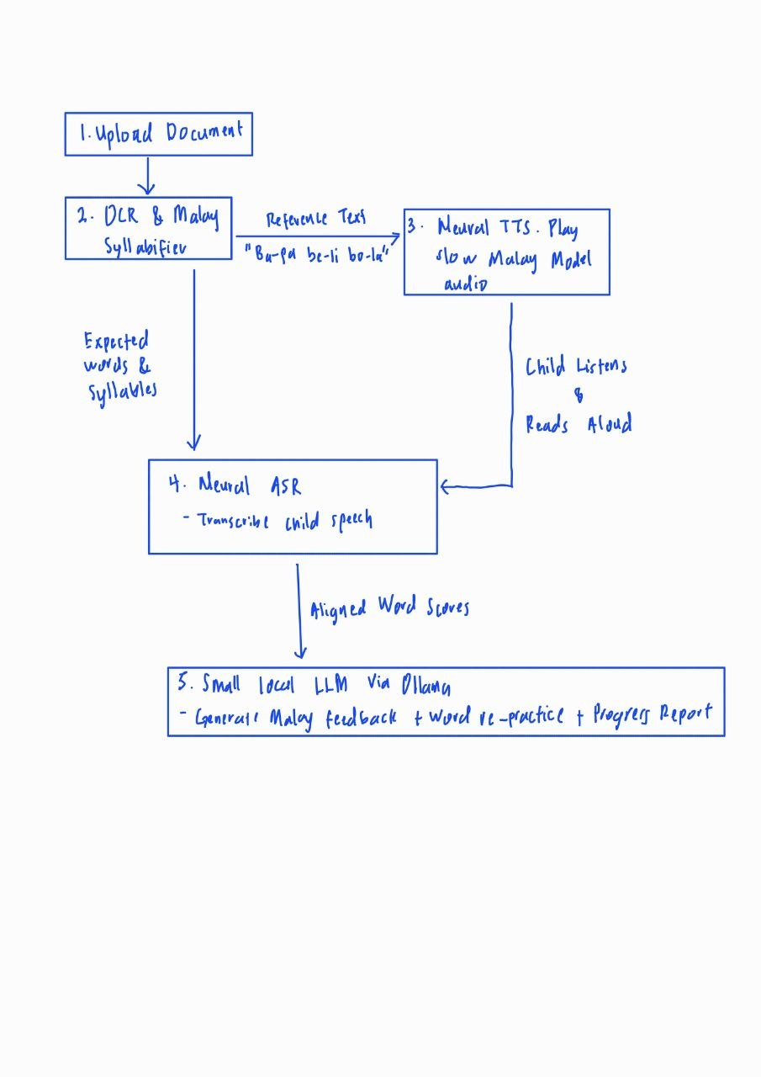
Sample Diagram

C2:
Frameworks,Models,Method, and Tools
Tool/Model/Framework/Method | Type | Role in BacaBuddy
OpenAI Whisper | Encoder-Decoder Transformer ASR Model | Used in its small or base variant to transcribe children's read aloud Malay speech into text tokens robustly even under mild home/classroom background noise.
wav2vec 2.0 | Self-Supervised Speech Representation Model (CTC) | Learns latent acoustic representations directly from raw audio waveforms and is fine-tuned using Connectionist Temporal Classification (CTC) on Malay speech to produce frame-level phoneme/character posteriors for pronunciation scoring.
WhisperX | Phoneme & Word-Level Forced Alignment Tool | Aligns the ASR acoustic output against the known OCR reference text to obtain exact millisecond word, pauses, and word-level pronunciation scores.
Meta MMS-TTS & Piper TTS | Neural Text-to-Speech | Variational Inference with adversarial learning for end to end Text-to-Speech (VITS) models that synthesise natural, clear Bahasa Melayu speech offline so the child can hear slow model reading for any uploaded sentence.
Ollama + Tesseract OCR | Local Lightweight LLM Runner & Optical Character Recognition Engine | Tesseract OCR extracts printed Malay text from uploaded page images/PDFs using LSTM line recognition, while Ollama runs to generate safe, encouraging Malay feedback from the alignment scores.

C3:
Fit To My Problem:
How Technology Solves Problem & Its Benefits
Combining OCR with a local Speech and NLP directly solves the reading problem faced by young Malaysian children, parents, and teachers. By combining Tesseract OCR with neural TTS and ASR the app does not depend on preloaded dataset. A teacher or parent can snap a photo or upload a PDF of any Bahasa Melayu textbook page, and the system turns it into an interactive reading lesson on the spot. Because teachers with 35 students cannot listen to every child read every day, ASR and forced alignment act as a personal reading helper. The app listens to the child read aloud, checks every word against the page and uses a local LLM to give friendly feedback in Malay right away. Due to all models are compressed to run locally on a normal laptop, schools and families do not need an internet connection or paid subscriptions, and children’s voice recordings are never uploaded to external cloud servers.
Limitations & Risks
Even though this technology fits my problem well, there are three main limitations and risks that must to be managed. Firstly, children aged 7 to 9 have higher pitched voices and less stable pronunciation than adults, so standard ASR models trained only on adult voices often make mistakes when listening to kids. Furthermore, no open Malay children's reading dataset currently exists. To manage this risk, this project builds my own dataset taking from 40-60 childrens voice and combines it with free public datasets such as speechocean762. Secondly, hardware limitation, running OCR, TTS, ASR, and an LLM on a laptop can cause the computer to slow down or run out of memory. To fix this, we use smaller model versions for all model we use during daily use. Thirdly, loud classroom noise can make the ASR model mishear a child's voice, and a dark or blurry phone photo of a book page can cause OCR spelling mistakes. To reduce this risk, users can edit the extracted OCR text before starting, and children can use a basic headset microphone.
Comparison Between BacaBuddy Technology and Paid Cloud API:
Category | BacaBuddy Technology | Paid Cloud API
Child voice privacy | High Privacy: Children's voice recordings stay 100% inside the laptop and never go online. | Low Privacy: Children's voice recordings must be sent to external company servers.
Internet requirement | Works Offline: Can be used in rural schools or homes without internet. | Needs Fast Internet: Stops working if the school Wi-Fi is slow or disconnected.
Cost | Free: Uses free open-source tools on a normal laptop. | Paid Subscription: Charges money for every minute of audio and every text prompt.
Training on Malay Child data | Flexible: We can fine-tune the model using our own dataset. | Locked: Closed commercial models cannot be custom trained on our dataset.
Hardware requirement | Needs a laptop with a dedicated GPU and small models. | Can run on a very weak computer because all heavy work happens on cloud servers.

I choose the BacaBuddy Technology over paid cloud API. Although cloud API are easier to run on weak computers, they fail to solve the core problems of our project, it send underage children’s voices to the cloud, require paid subscriptions and constant internet where many schools and families cannot afford, and do not allow us to train an open Malay child pronunciation model using our dataset. Running open source models locally keep the system free, private, offline, and tailored specifically for young Bahasa Melayu readers.

